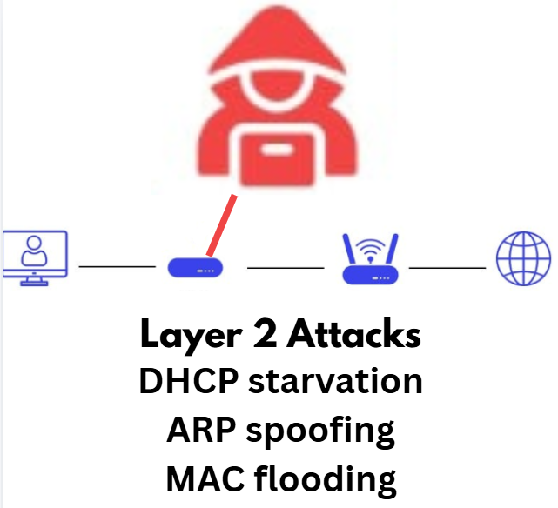Purpose
The purpose of this lab was to help us understand layer 2 attacks work in basic networks. Making us do 3 attacks helps us learn how multiple protocols work in layer 2, and the common vulnerabilities of each of the protocols. By having us configure mitigations, we are taught the necessary security measures to minimize the damage done.
Background Info
First let’s start with layer 2. Layer 2 networking is also known as the Data Link layer, because it is responsible for transferring data between devices on the same network. Layer 2 utilizes MAC (Media Access Control) addresses, which are unique codes identifying each network interface. Switches have a MAC address table that determines where they forward incoming traffic to the network.
Now let’s take a look at the protocols that must be known in this lab. ARP, which stands for Address Resolution Protocol, maps IP addresses to MAC addresses in a local network. If a device wants to send data to another, it sends an ARP Request that asks which MAC address corresponds to the IP address. The device with the IP address responds by sending an ARP Reply, and the two devices are then able to communicate. Both devices will then store this information in an ARP cache, which helps avoid repetition of the same requests.
Another protocol featured is DHCP (Dynamic Host Configuration Protocol). DHCP automatically assigns IP addresses to devices when they enter a network. It also provides the device with a subnet mask, default gateway, and DNS server. DHCP follows a sequence that can be remembered as DORA (Discover, Offer, Request, Acknowledge). DHCP is configured on the router and contains a pool of available IP addresses. One device is given one IP address until the pool runs out.
Now that we know the protocols, we must understand the attacks that are used in this lab. First, ARP Spoofing, also known as ARP poisoning, is an attack where a device sends fake ARP responses to a network. The attacker tries to say that it is actually their MAC address that matches with the real device’s IP address. The other devices then update their ARP tables, so that the attacker’s MAC address is associated with the real IP. The attacker then gets to perform what are known as “man-in-the-middle” attacks. They are able to intercept traffic, and then capture, monitor, and alter data that is in transit, which would pose a huge security risk. Additionally, they would be able to use other attacks from this position as well.
Next, let’s look at an attack called DHCP Starvation. DHCP Starvation is when an attacker sends an immense number of DHCP Discover requests using spoofed MAC addresses (the MAC address must be changed with each request). The router receiving the DHCP requests tries to respond to each request with a DHCP Offer, and an IP address is temporarily reserved. The DHCP attack used in this lab does not complete the handshake, so after a short time, the IP address is then unreserved. However, this DHCP attack does provide a continuous flow of fake clients, meaning the IP address will be taken up again and again. Eventually, the DHCP pool runs out of available IP addresses. This leads to legit devices not being able to connect to the network because they are unable to obtain an IP address. This attack is also called a Denial of Service (DoS) attack.
Lastly, a MAC Flooding attack targets the MAC address table of a switch. The attacker will send thousands of frames (flooding) with fake MAC addresses. This overloads the switch’s MAC address table, and it will become unable to learn new addresses. Since the switch cannot forward traffic properly, it is then forced to broadcast all traffic instead of sending it directly to the intended destination. This state is called “fail-open mode” and lets attackers capture data or distribute harmful content into the network.
Unfortunately, there is no sure-fire way to stop these attacks. There are only ways to mitigate the damage an attacker can do. Starting with MAC flooding attacks, you can configure Port Security and set the maximum number of addresses to a low number, like 2 or 3 depending on your network. You can also tell the switch what to do once this number is surpassed (which means that an extra device is trying to communicate with your switch). For example, “switchport port-security violation shutdown” tells the switch to shut down the port if the maximum number is violated.
Similarly to MAC flooding attacks, ARP spoofing attacks can also be mitigated using Port Security. Since ARP spoofing attacks also use MAC addresses to try to fool the switch, Port Security is helpful in preventing the attacker from assuming multiple identities. Other ways to prevent ARP spoofing attacks include Dynamic Arp Inspection (DAI). DAI basically manages ARP packets and validates them to prevent unauthorized ARP requests. It can also limit the rate that ARP requests are sent through the switch, which is very effective against ARP request spam. DAI should be enabled on all ports except those connected to another switch. Another technique that can be implemented is a static ARP table. This is really only helpful in a small and unchanging network, as any change in the network would require manually updating ARP tables across many hosts, which would be almost impossible in a larger network.
Lastly, DHCP Starvation can be mitigated by enabling DHCP Snooping on the switch that connects clients to the DHCP server. DHCP Snooping is a protocol that examines all DHCP information that is passing through the switch, while only allowing approved packets from trusted origins to the clients.
Lab Summary
In this lab, a local network was set up to discover the vulnerabilities of the Layer 2 level. The network had multiple hosts connected to a switch, which is then connected to a router that acted as a DHCP server. Attacks were done through a virtual machine (VM). The lab demonstrated three types of Layer 2 attacks: ARP spoofing, DHCP starvation, and MAC flooding.
ARP spoofing was done by sending ARP messages to associate the VM’s MAC address with the IP address of another device, which then allowed traffic to be intercepted by the VM. DHCP starvation was performed by sending a large number of DHCP requests. This led to an empty DHCP pool on the router, which prevented real devices from getting their network configurations. Lastly, a MAC flooding attack was done by sending frames with fake MAC addresses to the switch, effectively overwhelming it’s MAC address table. The switch will then broadcast traffic, which allows the VM to see traffic that it normally wouldn’t be able to see.
Lab Commands



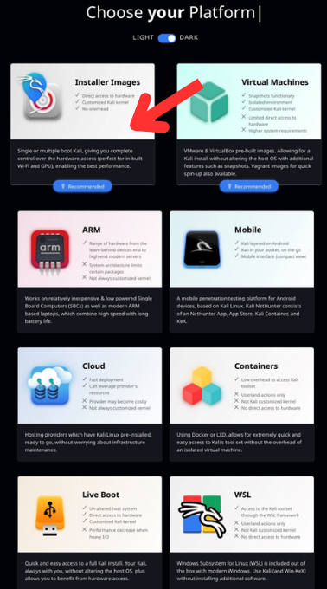

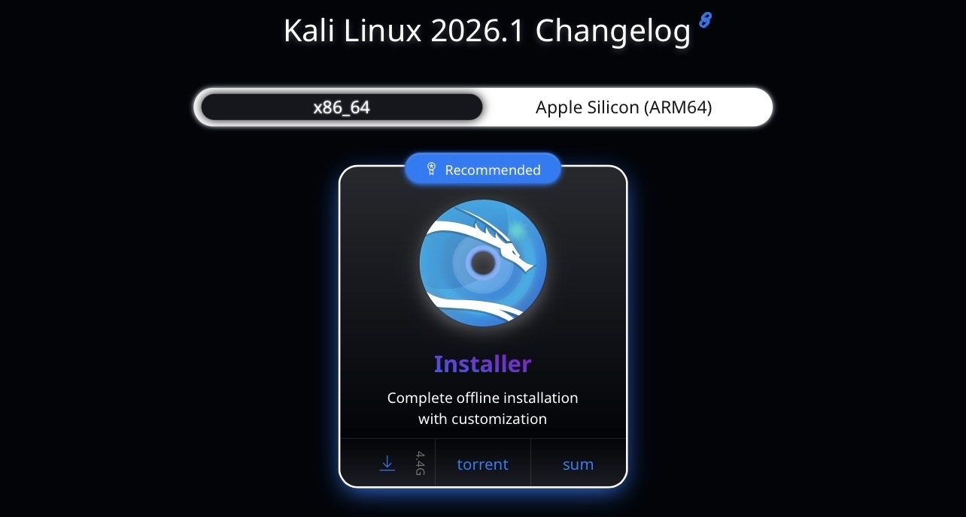
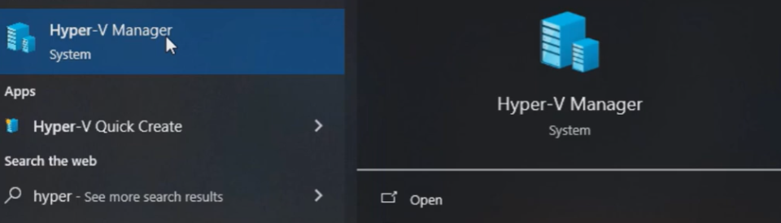
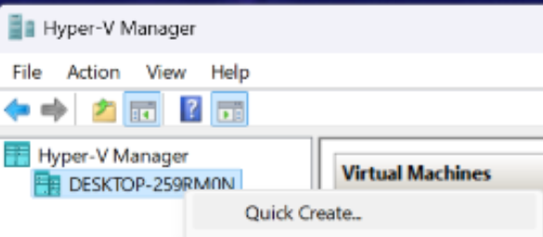
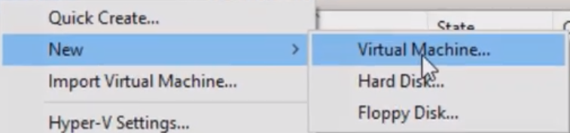
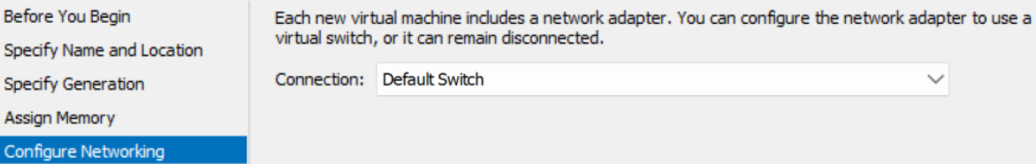
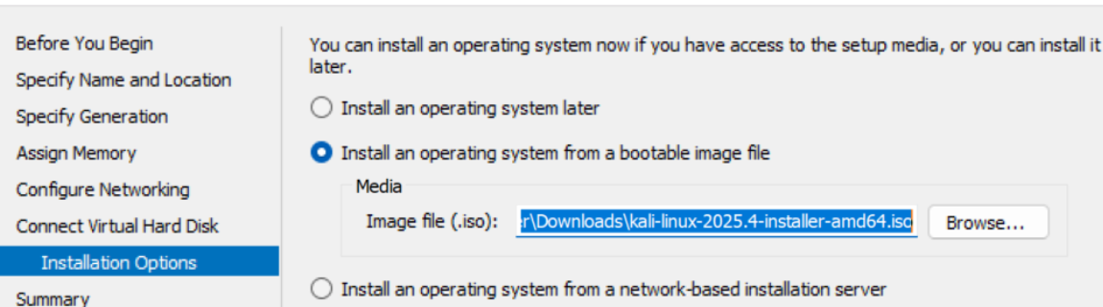
The setup is now complete and Kali can be booted up. The main screen should look like this:

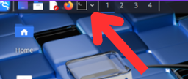
arp -a
Displays the ARP cache
switchport mode access
Configures the port as an access port
switchport port-security
Enables port security on an interface
switchport port-security maximum <number>
Limits the number of MAC addresses on the port. In this lab, the number was 3.
switchport port-security violation (restrict, protect, or shutdown)
When a violation occurs, this command (depending on whether you choose restrict, protect, or shutdown) will make the port go into a different way of forwarding messages.
- Restrict: permits traffic from known MAC addresses while dropping packets from unknown MAC addresses
- Protect: The interface remains online. The unallowed traffic is dropped and other traffic is allowed through
- Shutdown: the port is disabled and stops forwarding all traffic.
Shutdown violation was used in this lab:
ip dhcp snooping
Enables DHCP snooping
ip dhcp snooping trust
Marks the interface as trusted, meaning it is allowed to send DHCP responses
ip arp inspection vlan <name>
Enables ARP inspection on a VLAN
ip arp inspection trust
Allows traffic through the port without inspection
sudo yersinia -I
Launches Yersinia to perform DHCP starvation. Choose “DHCP” -> “sending DISCOVER packet”
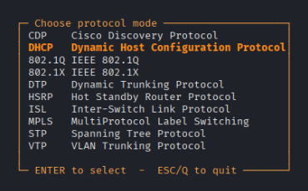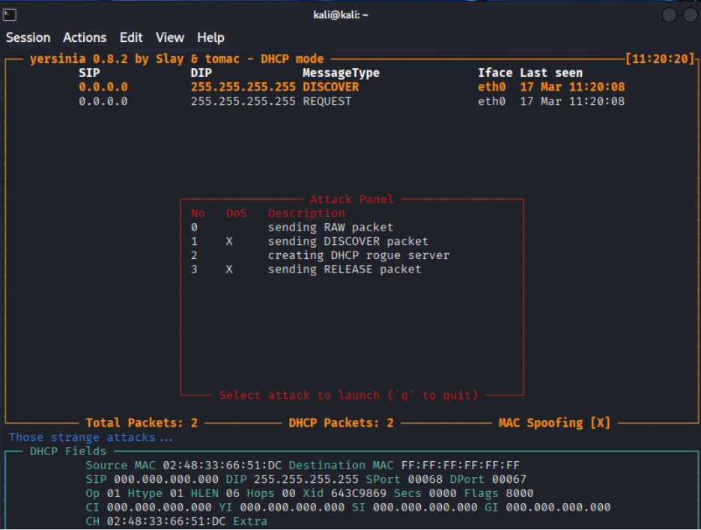
The result should look like this:
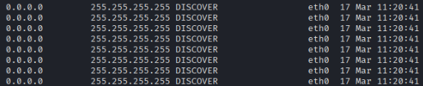
sudo arpspoof -I eth0
Spams the victim with fake ARP replies
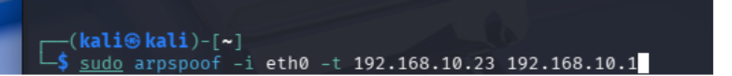
sudo macof -I
Floods the switch with frames of random MAC addresses
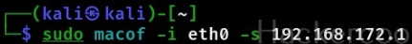
sudo wireshark
Launches Wireshark, which is used to capture and analyze packets.

Network Diagram
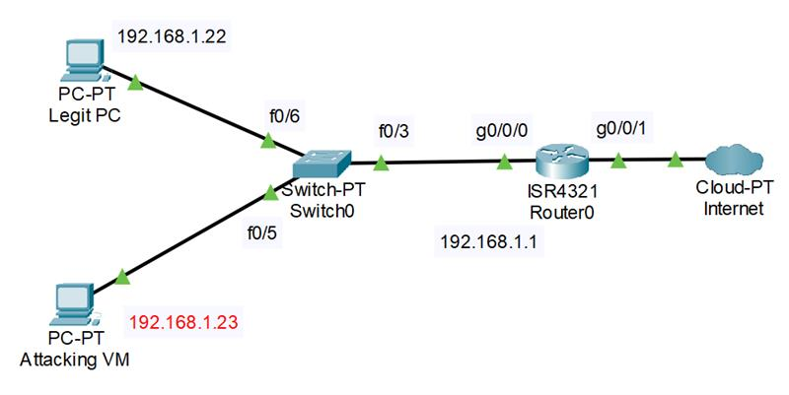
Configurations
After configuring the mitigations to each attack, the switch configuration will look like this:
Switch(config)#do show run
Building configuration...

Current configuration : 1833 bytes
!
version 15.0
no service timestamps log datetime msec
no service timestamps debug datetime msec
no service password-encryption
!
hostname Switch
!
!
!
!
ip arp inspection vlan 1
!
ip dhcp snooping vlan 1
ip dhcp snooping
!
spanning-tree mode pvst
spanning-tree extend system-id
!
interface FastEthernet0/1
switchport mode access
switchport port-security
switchport port-security maximum 2
!
interface FastEthernet0/2
switchport mode access
!
interface FastEthernet0/3
ip arp inspection trust
ip dhcp snooping trust
switchport mode access
!
interface FastEthernet0/4
switchport mode access
!
interface FastEthernet0/5
switchport mode access
!
interface FastEthernet0/6
switchport mode access
!
interface FastEthernet0/7
switchport mode access
!
interface FastEthernet0/8
switchport mode access
!
interface FastEthernet0/9
switchport mode access
!
interface FastEthernet0/10
switchport mode access
!
interface FastEthernet0/11
switchport mode access
!
interface FastEthernet0/12
switchport mode access
!
interface FastEthernet0/13
switchport mode access
!
interface FastEthernet0/14
switchport mode access
!
interface FastEthernet0/15
switchport mode access
!
interface FastEthernet0/16
switchport mode access
!
interface FastEthernet0/17
switchport mode access
!
interface FastEthernet0/18
switchport mode access
!
interface FastEthernet0/19
switchport mode access
!
interface FastEthernet0/20
switchport mode access
!
interface FastEthernet0/21
switchport mode access
!
interface FastEthernet0/22
switchport mode access
!
interface FastEthernet0/23
switchport mode access
!
interface FastEthernet0/24
switchport mode access
!
interface GigabitEthernet0/1
!
interface GigabitEthernet0/2
!
interface Vlan1
no ip address
shutdown
!
!
!
!
line con 0
!
line vty 0 4
login
line vty 5 15
login
!
!
!
!
End
The Router configuration will look like this:
Router#show run
Building configuration...

Current configuration : 697 bytes
!
version 15.4
no service timestamps log datetime msec
no service timestamps debug datetime msec
no service password-encryption
!
hostname Router
!
!
!
!
ip dhcp excluded-address 192.168.1.1 192.168.1.20
!
ip dhcp pool ANDREW
network 192.168.1.0 255.255.255.0
default-router 192.168.1.1
dns-server 8.8.8.8
!
!
!
ip cef
no ipv6 cef
!
!
!
!
!
!
!
!
!
!
!
!
spanning-tree mode pvst
!
!
!
!
!
!
interface GigabitEthernet0/0/0
ip address 192.168.1.1 255.255.255.0
duplex auto
speed auto
!
interface GigabitEthernet0/0/1
no ip address
duplex auto
speed auto
!
interface Vlan1
no ip address
shutdown
!
ip classless
!
ip flow-export version 9
!
!
!
!
!
!
!
line con 0
!
line aux 0
!
line vty 0 4
login
!
!
!
end
Problems
One of the problems that I faced was that none of the attack commands worked. Initially, I thought there was something wrong with the interface itself, so I went through the switch and router repeatedly, but I found nothing wrong with the configurations. I then decided to look at my topology that I had pulled up on an adjacent screen to map out the route of the attack. When I checked the attack command that I was using on Yersinia, I realized that I was sending the attack through the wrong interface. This was a stupid mistake but having a digital topology of what I was doing was incredibly helpful for me to visualize what is actually happening.
Conclusion
This lab focuses on Layer 2 network attacks and exploring the vulnerabilities of switches. In a small network of a router, switch, and multiple hosts, ARP spoofing, DHCP starvation, and MAC flooding attacks were performed from a Kali Linux machine and the impact on the network was observed through Wireshark. Things that went well were the before-and-after configuration of mitigations that were clearly observed in the network captures on Wireshark. Something that was confusing was which port to configure the mitigations on. Going through the mitigation configurations was instructive to reinforcing my understanding of Layer 2 attacks and the function of the mitigations.

